# Neural Networks

## Neurons and Artificial Neurons

Neurons   
  
. basic working units of the brain, transmit information to other nerve cells

. they are excitable - this means they produce electrical events called action potentials or nerve impulses.

. communicate by sending out an electrical signal starting a chain reaction when stimulated by signals

. every neuron picks up the signal and passes it on to the next neuron in the path.

. The dendrites pick up the impulse and send the message to the axon which delivers it to the next neuron.

. once the signal hits its target a neurotransmitter is stimulated and causes action

### How Humans Learn

### 



Frontal Lobe

Ability to concentrate, judgement, problem solving, analysis, personality.

#### Temporal Lobe

Deals with high level visual processing (faces and scenes)

#### Brain Stem

Warning system - sets alertness

Cerebellum  
  
Perform some cognitive function, attention to language ad voluntary movement

Occipital Love  
  
Visual processing centre (Visual Cortex)

n

#### Parietal lobe

integrate information from several senses, speech, pain, touch etc...

## Gradient Descent

### Perceptron (Artificial Neuron)

Made up of a weighted sum of inputs: the inputs being x1, x2… xn and the weights being w1, w2…. Wn.

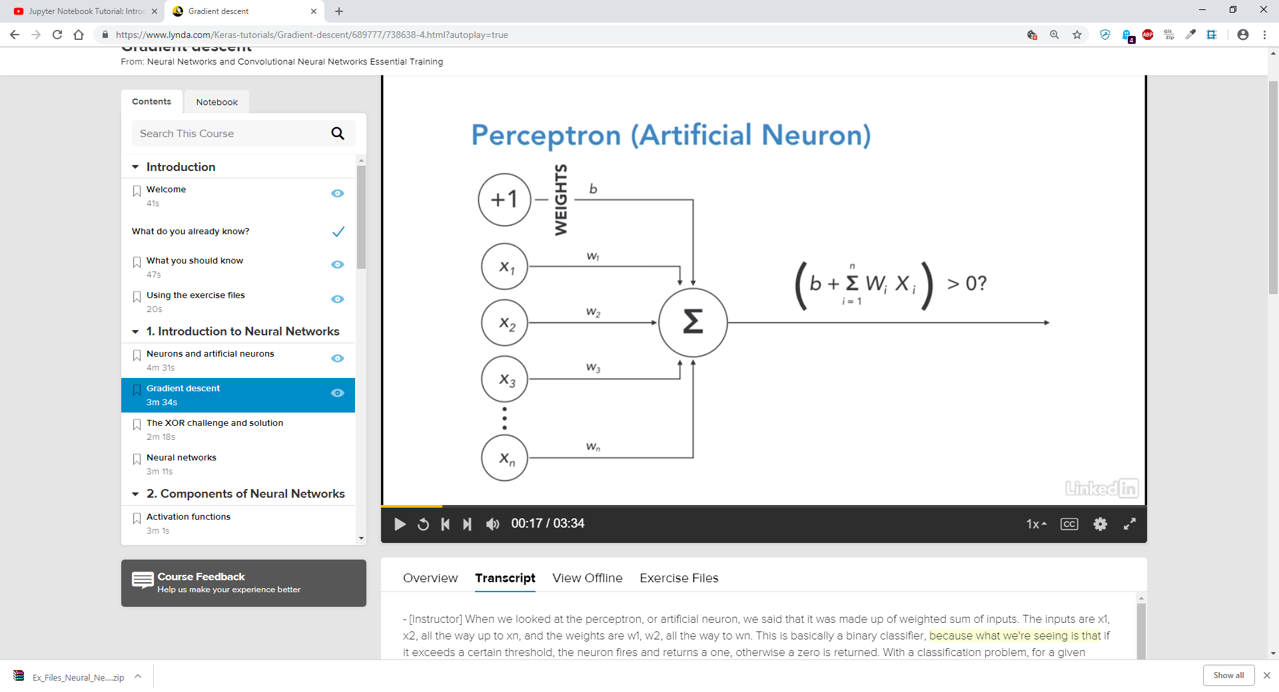

This is basically a binary classifier, as if a certain threshold is exceeded the neuron fires and returns a 1 otherwise a 0 is returned.

### Understanding Loss

With a classification problem for a given input we know what the actual output is.

When we pass the same input into our model we then have a predicted output.

We call the difference between these two outputs the loss.

In order to improve our model’s prediction capabilities, we want to minimise this loss.   
  
We can change our predictions by changing the weights within the model.

One of the things we need to do is to learn a neurons weights and parameters (weight and bias) we can use a loss function to quantify the loss, and take the gradient of this loss function to determine where we can minimise the loss.

Gradient Descent is an optimising algorithm which is used to iterate through different combinations of weights to find the best combination which minuses this loss/error.   
  
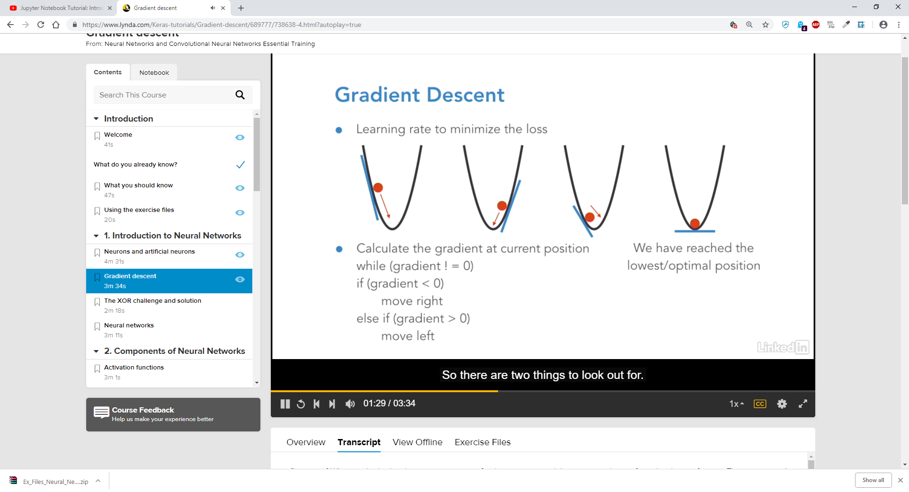

If you some way of quantifying the error your network makes on training data (the differential loss function) then we can take the gradient of this loss function with respect to the weights and update our weights slowly in the direction of the gradient, allowing us to find the minimum of the loss function improving predictability.   
  
There are two things we need to watch for: which direction to go to get the minimum of the loss function and the learning rate which tells us how big the steps should be to get there.

### Loss Function

If you are on the left of the curve in the above model we know that the gradient/slope of the line is negative, in order to achieve the minimum we want we have to move the ball further down the curve, if the opposite is true we must move the ball to the left of the curve. When the ball is at the bottom of the slope we have reached the lowest position and minimised the loss function.   
  
Learning Rate  
  
The learning rate defines the size of the steps we take to reach a local minimum.  
  
From the perceptron model earlier the outputs over a certain threshold will either be a one or a zero. But if we want to apply gradient descent from the model we have just looked at we need to be able to take gradients or the slope. Because the output is just either a zero or a one this is really just a step function meaning the gradient is not differentiable at any certain point.

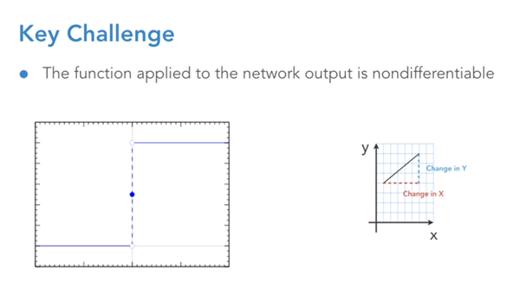  
  
The gradient is equivalent to the change in Y divided by the change in X $$Gradient=\frac{Change in Y}{Change in X}$$

If we wanted to find the slope at a point where the output changes from zero to one, you are going from 0 to 1 without moving along the X axis, in other words we are dividing a number by 0 which is not defined mathematically.   
  
There are no points in which you can differentiate the step function, this is a challenge for which a workaround is needed.   
  
  
Logistic Sigmoid Function

A workaround is to use the Logistic Sigmoid function, like the previous network it will give a value of zero or one where the cut off part can be the halfway point.  
  
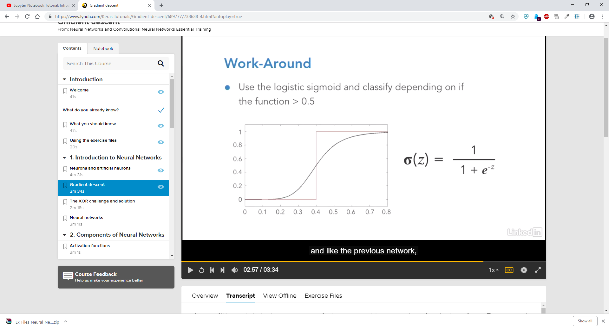

. If we do not know anything about the problem it is possible to use the squared error loss function  
  
. The cross-entropy loss function is better suited for logistic functions.   
  
  
XOR Challenge

With a single Perceptron we are making a linear combination of our inputs.

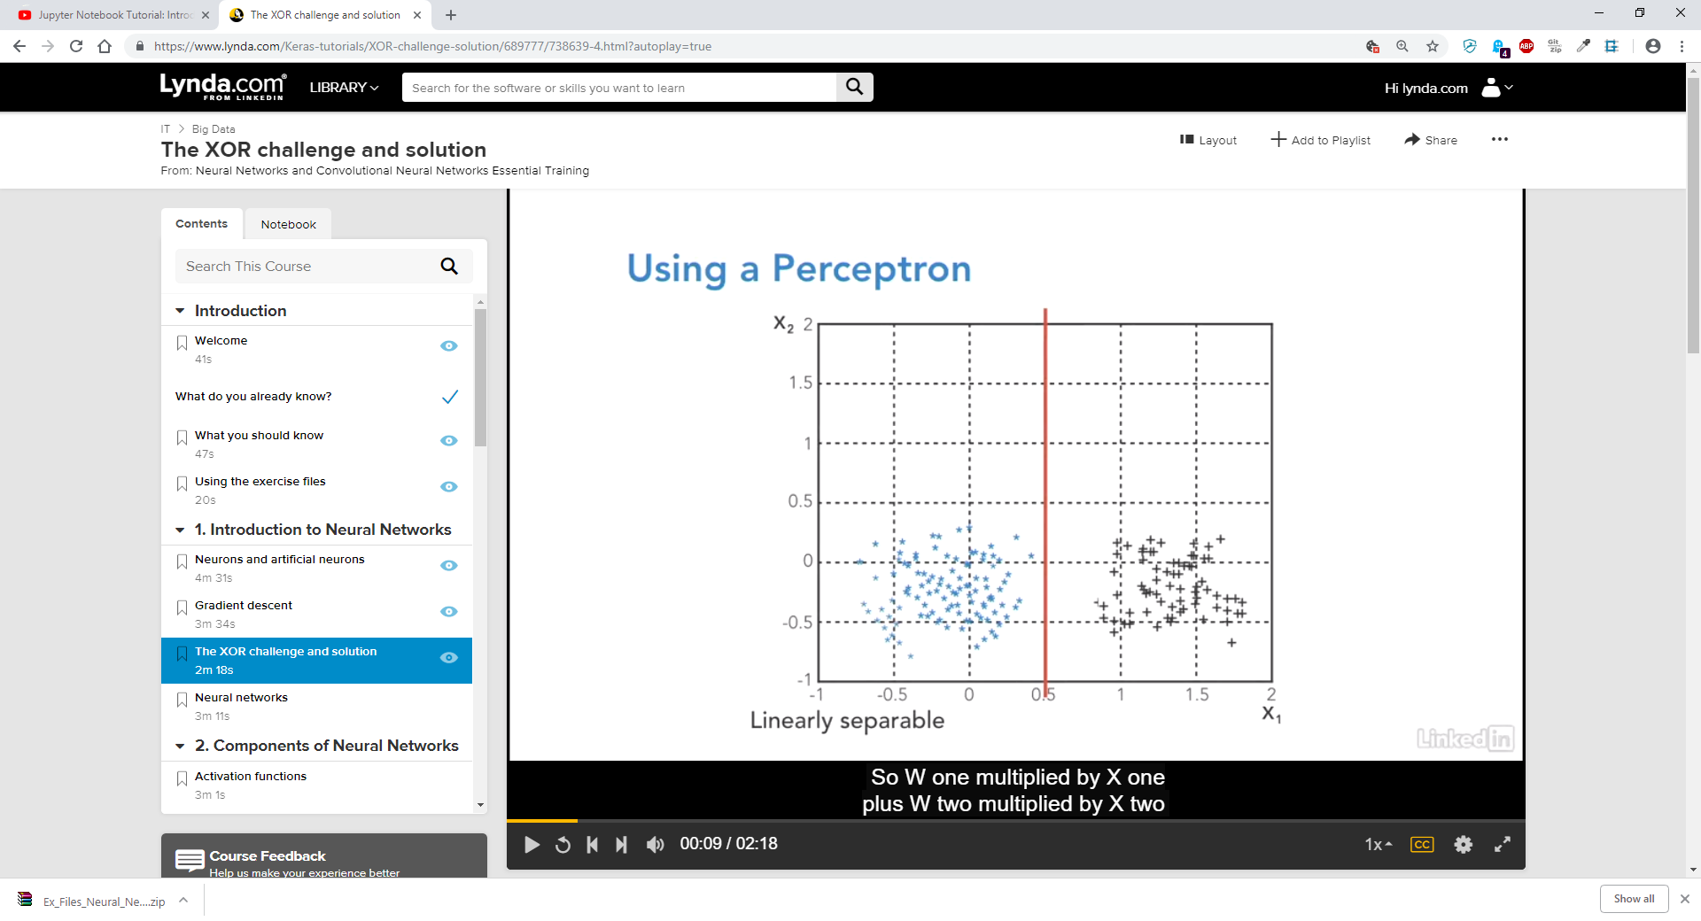  
  
I.e. W1 * X1 + W2 * X2 + W3 * X3….. + bias

If we want to visualise our input in two dimensions we put the x1 on the x axis and the x2 on the Y axis.

If your outputs were then these two classes, one with black and one with blue we have a classification problem.  
  
What we want to do is determine some way to separate the blues from the blacks. (I,e, drawing a red line)

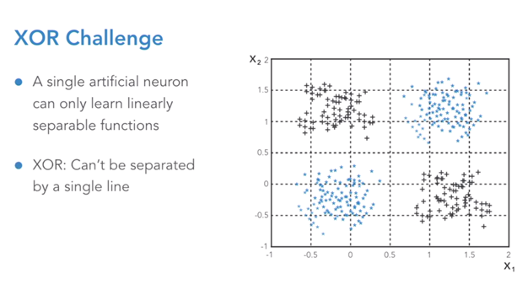  
  
Visualising X1 and X2 we should be able to separate these two outputs with a single line. While it is clear you can separate the two classes of data here, it is not possible to draw a straight line to separate the output.   
  
Researchers soon found that using a binary classifier such as a singular artificial neuron there was no linear function that could be applied to separate the blue from the black.  
  
Researchers assumed AI had no value as they did not believe it could solve a simple problem such as this. This issue is responsible for the “cold and dark winter of AI research” from 1970 to 1985.

It was clear we needed to introduce some non-linear functionality.

How do we extend from a single neuron?

. We connect the outputs of a neuron so that it is the input to another neuron, also by introducing non-linear functions within a neural network they are able to distinguish between outputs without using a straight line.

## Neural Networks

In extending from a single neuron to a neuron network we define a Multilayer Perceptron.   
  
  
Multilayer Perceptron

. Perceptron’s are divided into multiple layers.

. The output of one Perceptron will be the input to another Perceptron, we say this is a fully connected layer and so each layer processes all of the outputs from the previous layer.

. Each of the Perceptron’s in the diagram behave in the same way as the single Perceptron.

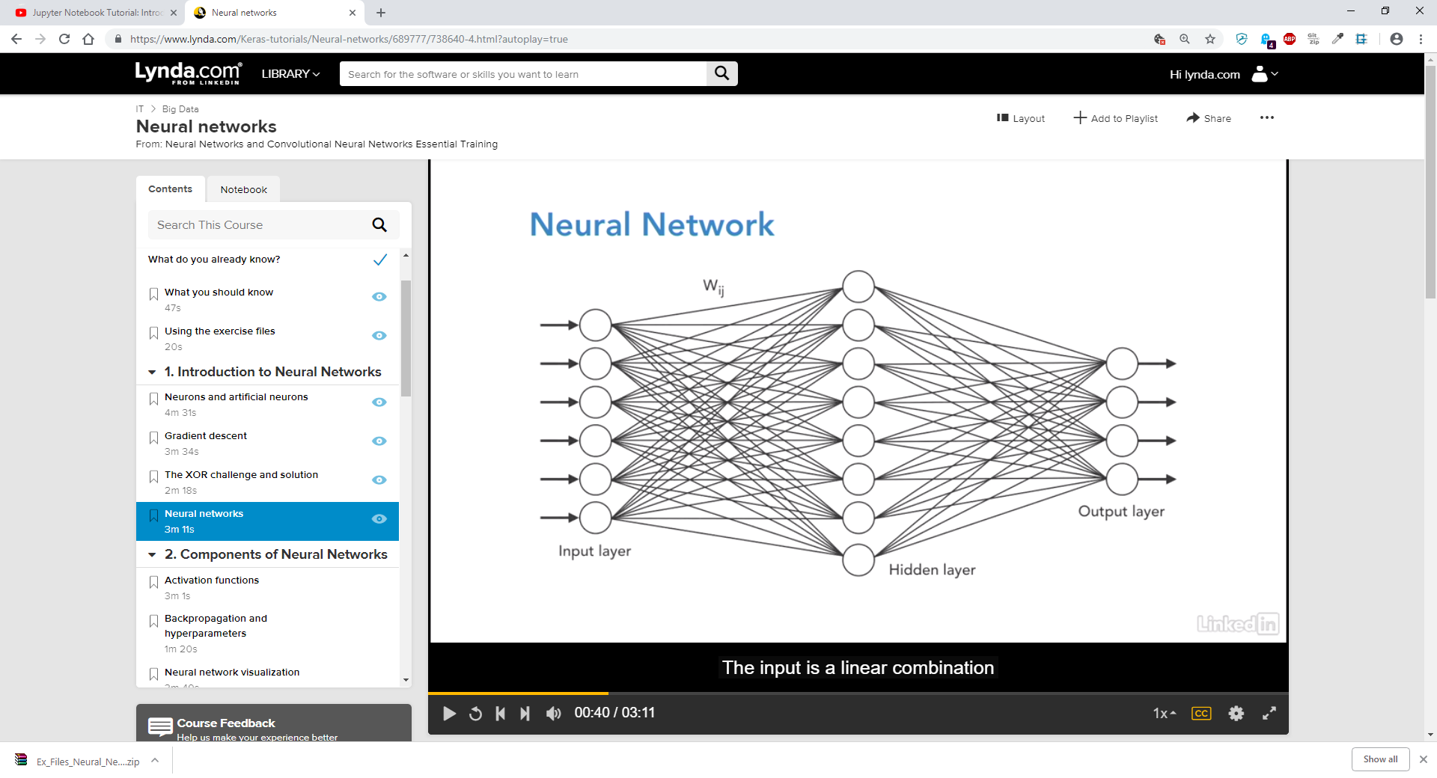  
The input is a linear combination of the sum of products of the weight times the input, the input to this Perceptron is a linear combination of all of the outputs multiplied by a weight (indicated by Wij) of Perceptron’s from the previous layer. The output from this perceptron is then connected to all of the Perceptron’s in the next layer.   
  
We introduce the non-linearity by ensuring that the activation function we use (the function that determines if a neuron triggers or not) is non-linear.  
  
We have an input layer   
  
An output layer

And any layers which may be in between are defined as the Hidden layers  
  
A Deep Neural Network is defined as a Neural Network with one or more hidden layers.   
  
  
Given the set of inputs and outputs to a network, how many layers are sufficient to learn any function?  
  
  
Cybenkos Theorem (1989): suggested that a single hidden layer was sufficient.   
  
The implications of this were sufficient, this means that a Neural Network with only one hidden layer can predict an output, or a close approximation of an output, even if the output is complex.   
  
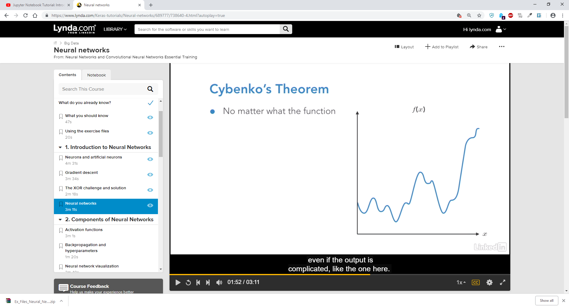

Cybenkos Theorem states that you need only one hidden layer to create a model with a close approximation.

What you actually find is that many popular Neural Networks have 10, 20, 50 or even more hidden layers, as these models can provide more accurate results.

## Why the Hype Now?

Deep Learning has kicked off in such a significant way over the last few years due to, Firstly: the availability of massive amounts of labelled image data and secondly the massive improvement of GPU computing capabilities with vendors such as NVIDIA.   
  
  


Activation Functions

An artificial neuron (Perceptron) performs the weighted sums calculations.  
  
The Activation Function determined whether or not a neuron “Activates” in other words whether it fires or not.   
  
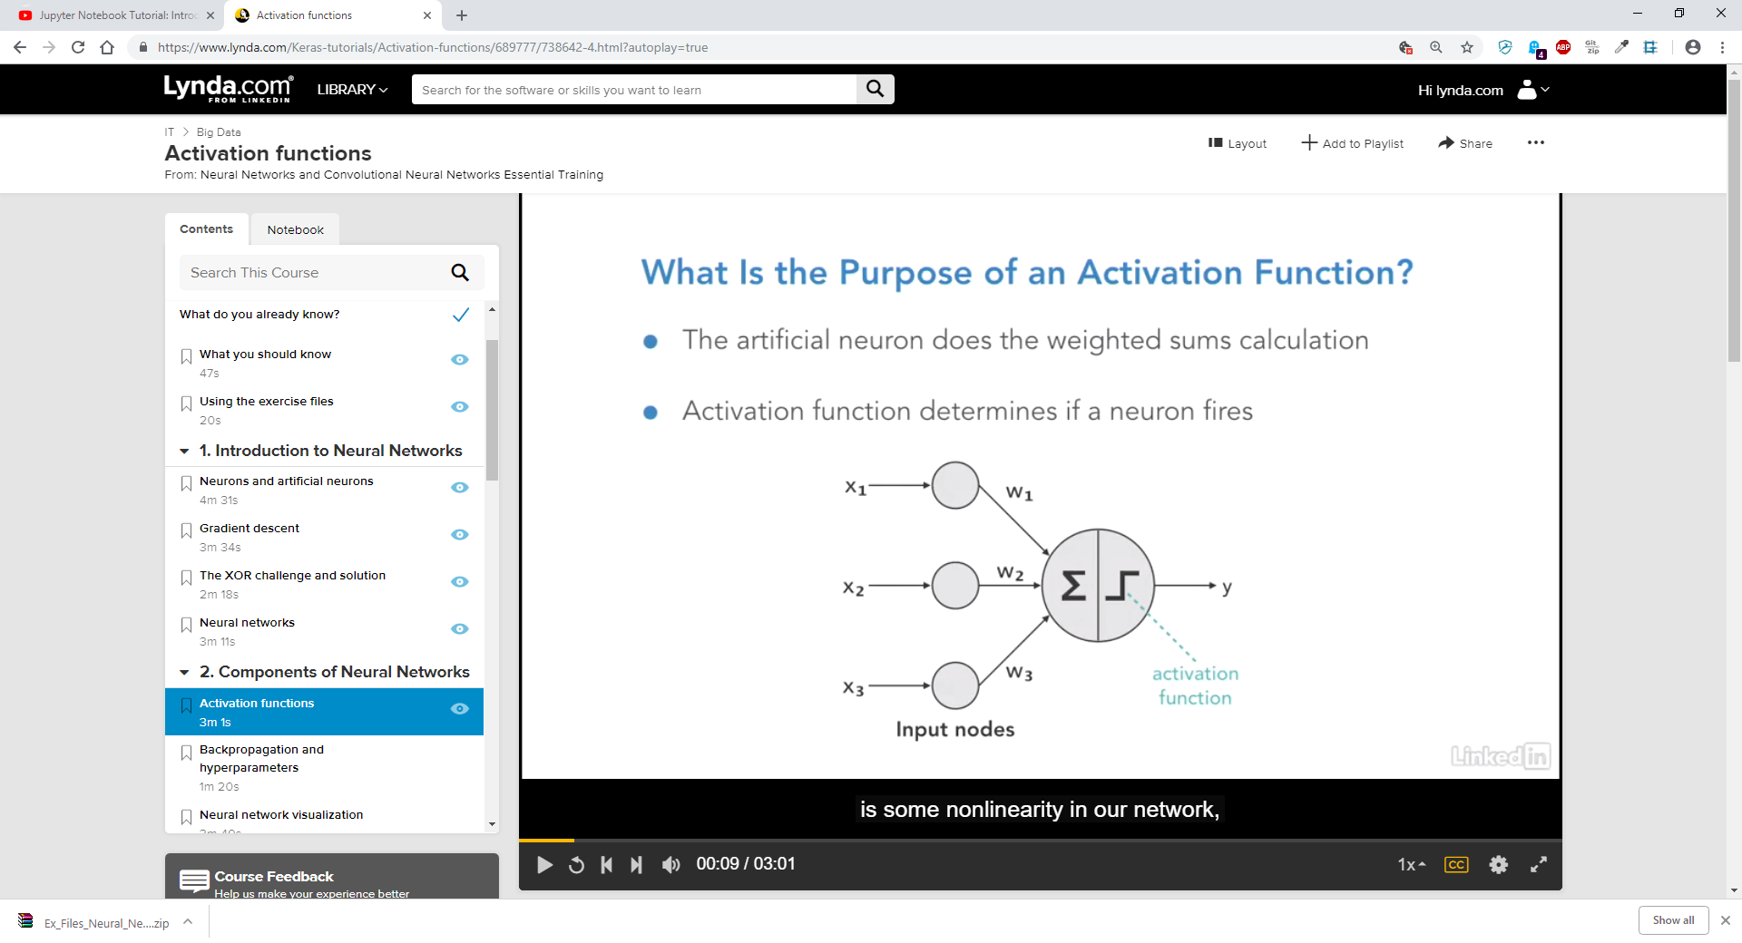  
  
To ensure there is some non-linearity in our network, we need to ensure that these activation functions are non-linear.  
  
Step Function

We could use the Step Function as our activation function: it provides an output of 0 or 1

If the output is above a certain threshold the neuron is fired and we have a one, otherwise the value is less than the threshold and the neuron has not fired so we have a 0.   
  


## What if the output needs to be multiple classes and not just two?

We can use a function that provides a number of discrete outputs or classes.  
  
For example: Answers could range from 0 – 9 rather than 0 – 1

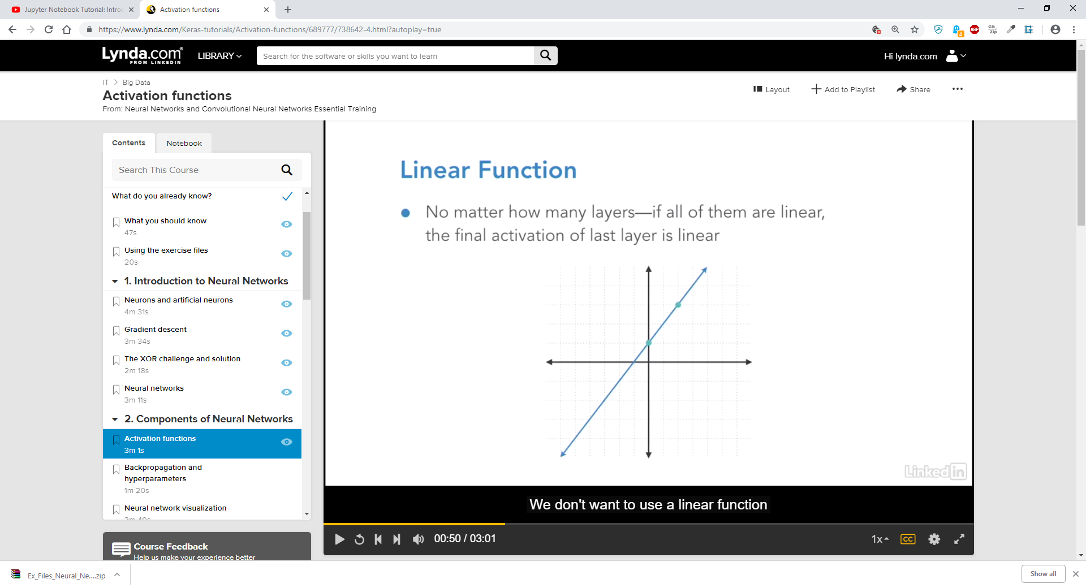  
  
We do not however want to use a linear function. As we will end up with the XOR problem. Additionally, multiple layers with linear activation functions can be replaced by a single linear function.  
  
Sigmoid Function

With the Sigmoid Function, the output is between 0 and 1, this is good for binary operations as your output is 0 and 1 or true and false.   
  
The problem here is what is known as vanishing gradient. This is when near the boundaries the network is not very quick to learn. This is because the gradient is almost 0 at both ends.   
  
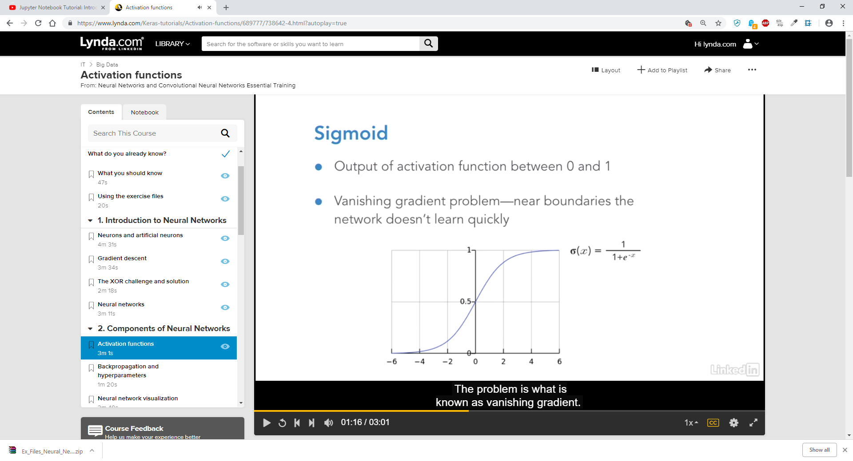

## Tanh (Hyperbolic Tangent)

Tanh is another possible non-linear activation function.   
  
Where Sigmoid has an output between zero and one Tanh is defined in terms of exponents and has an output between -1 and 1 as the outputs are not 0 and 1 (true and false) it does not lend itself as well to binary operations as Sigmoid.

Additionally, a Tanh function can be made up of Sigmoids, this means that as Sigmoids suffer the vanishing gradient problem, this will apply to Tanh too.

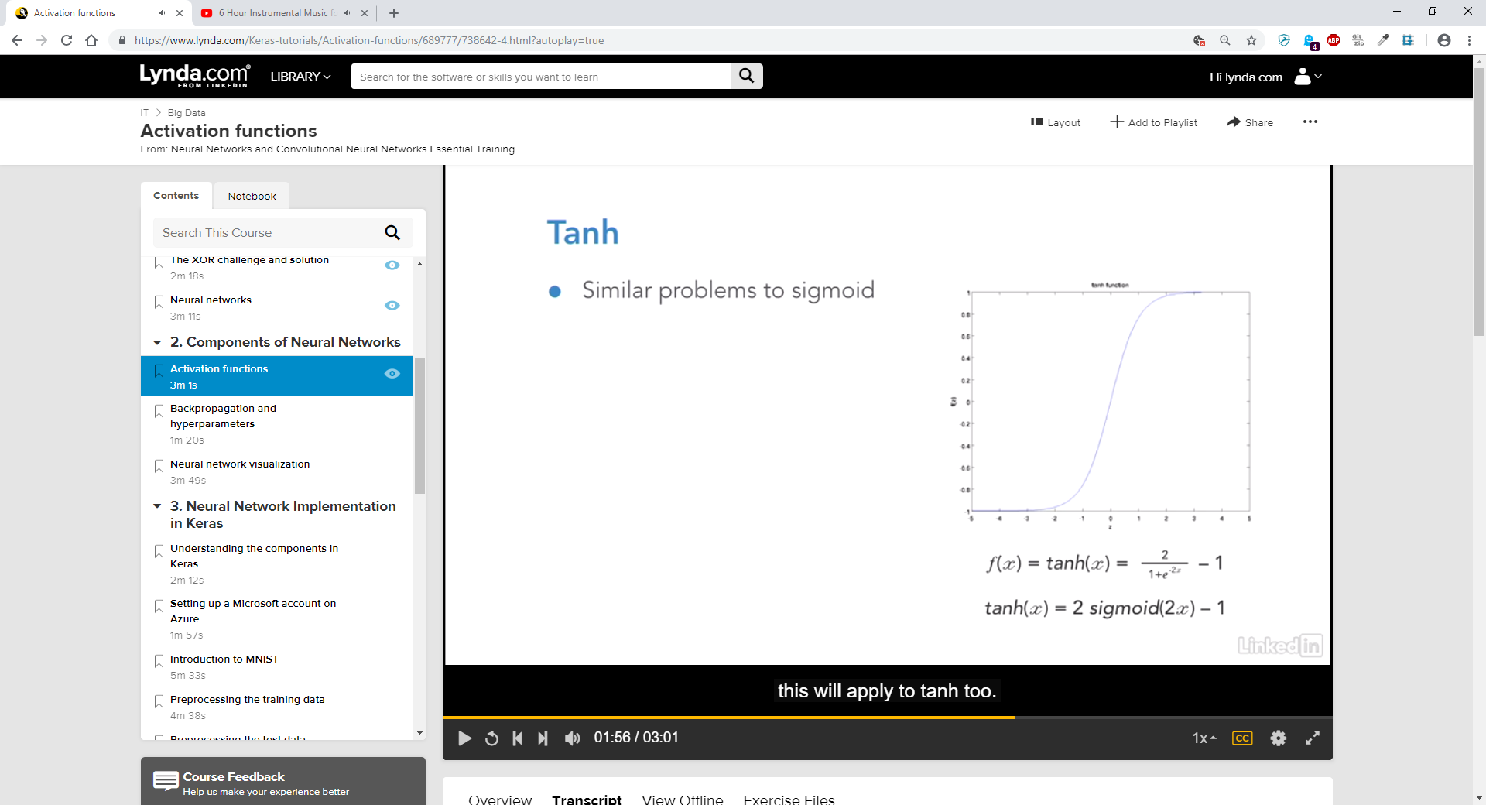

## ReLU (Rectified Linear Unit)

The Rectified Linear Unit is defined as outputting a 0 for any value of x that is less than 0  
  
if( x < 0 ) {

Return 0;

}

For any value which is equal to or greater than 0 the function returns an x

if( x >= 0 ) {

Return x;

}

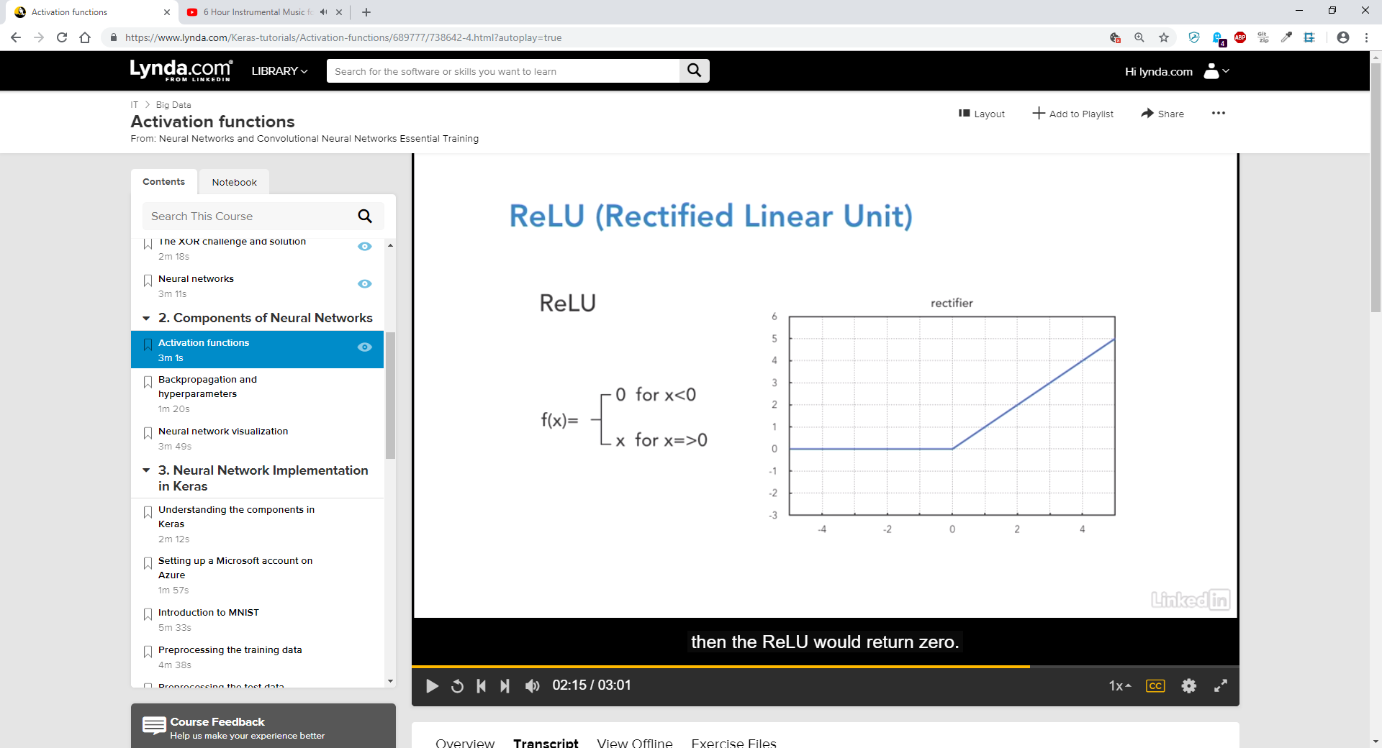

You may think that the ReLU has the same problems as linear functions when first looking at it, however ReLU is non-linear and combinations of ReLU are non-linear. ReLU is one of the more well-known and use activation functions.   
  
When deciding which activation function to use you will need to experiment and decide which yields the best performance for the particular model. However ReLU is a good starting point as it has good performance in many instances.

# Backpropagation and Hyperparameters

Introduced in 1985 by Hinton, Rumelhart and Williams.  
  
We have our input to the neural network and out neural network provides with some output, we then want to compare that to the expected (actual) output. We compute the Loss Function and take a gradient of the Loss Function, we can then compute it for the weights of the output neuron directly. The Backwards part of the name is because the calculation of the gradient proceeds backwards throughout the network

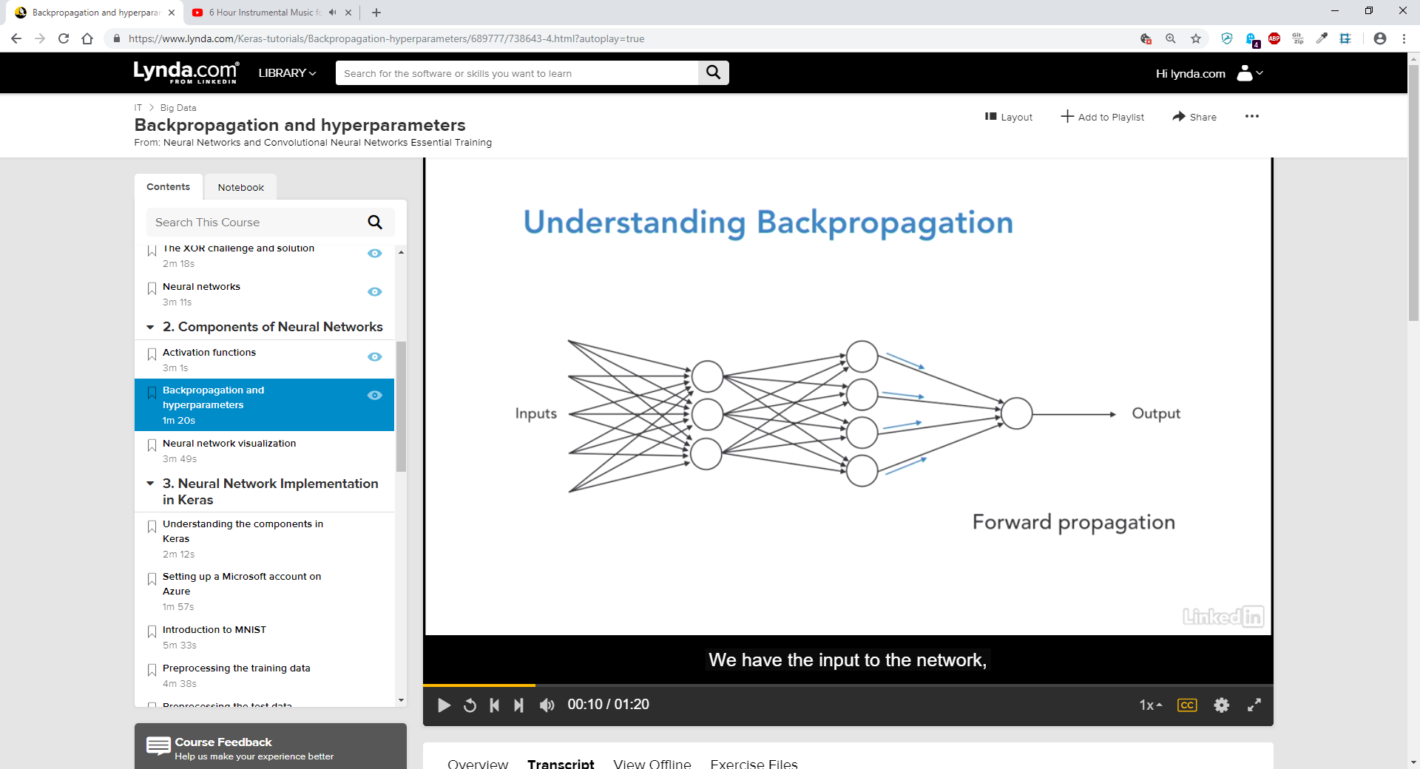  
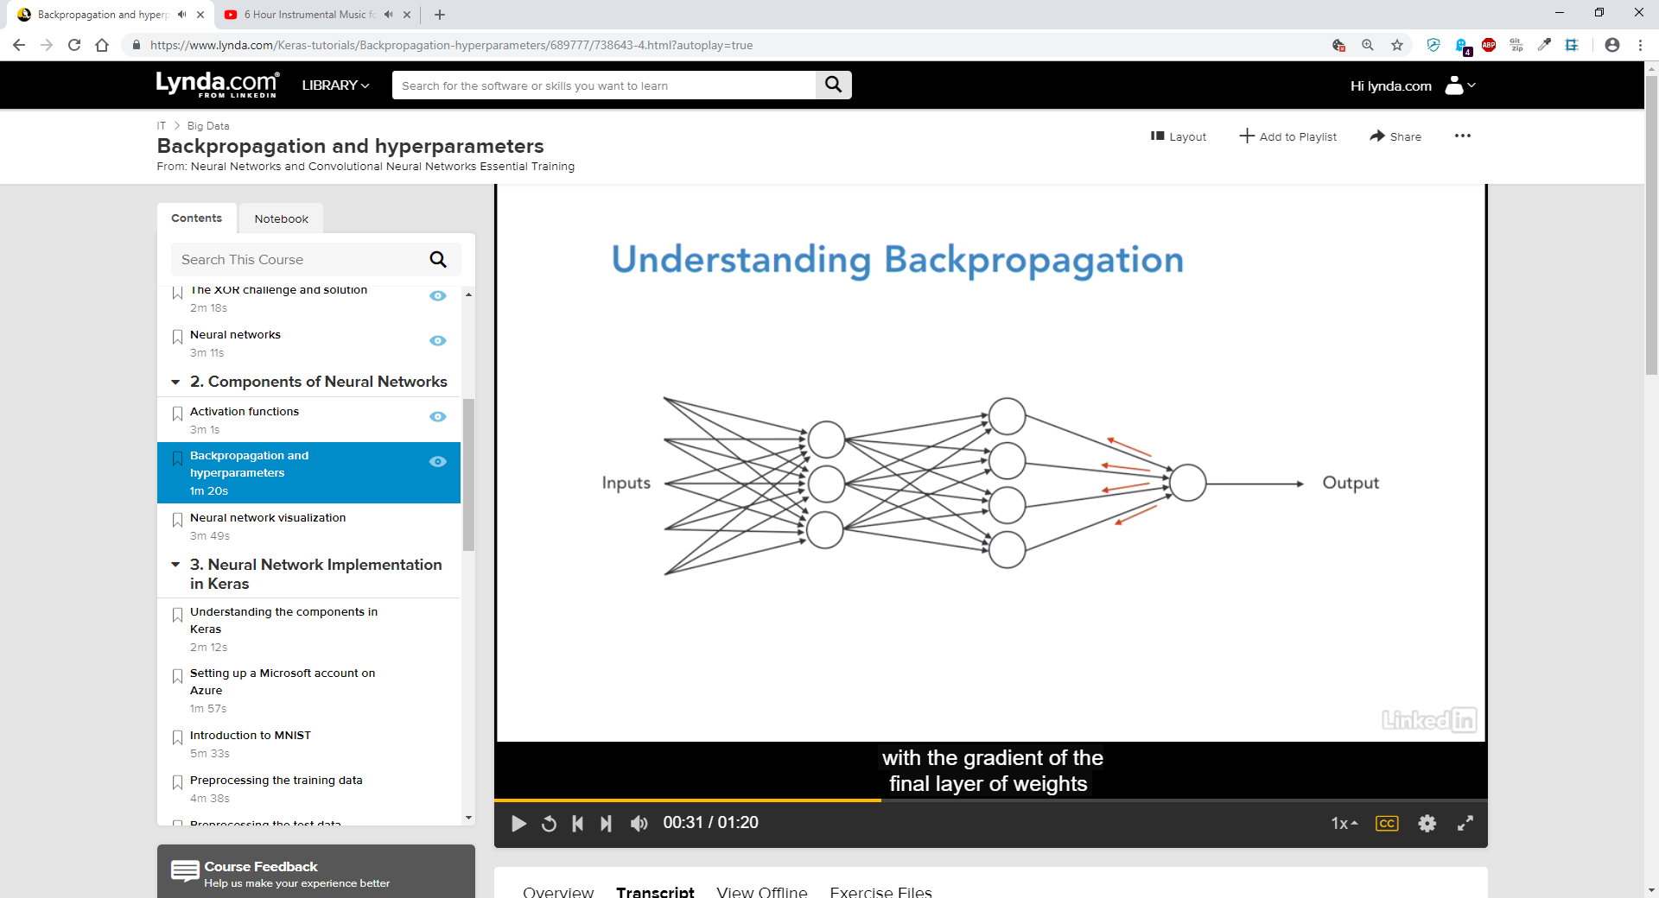  
with the gradient of the final layer of weight being calculated first, and the first layer of weights being calculated last. Partial computations of the gradient from one layer are reused in the computation for the gradient in the previous layer. This backward flow of the error information allows for efficient computation of the gradient at each layer.   
  
  
  
  
  
  
  
  
Hyperparameters

In machine learning Hyperparameters are parameters whose value is set before the learning process begins. There are several Hyperparameters of which we need to specify.

* The activation function we want to use for the neurons.
* The learning rate we want to use
* How many neurons in each layer
* How many hidden layers

# Playgorund.Tensorflow.org

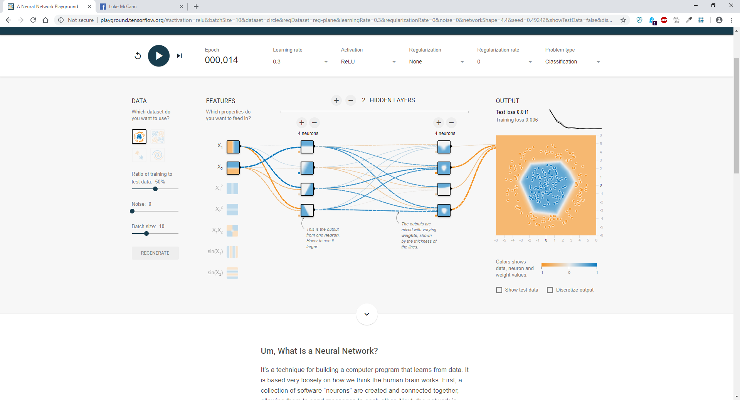

# Keras

A high-level neural network API, written in Python and capable of running atop of TensorFlow, Theano or CNTK.

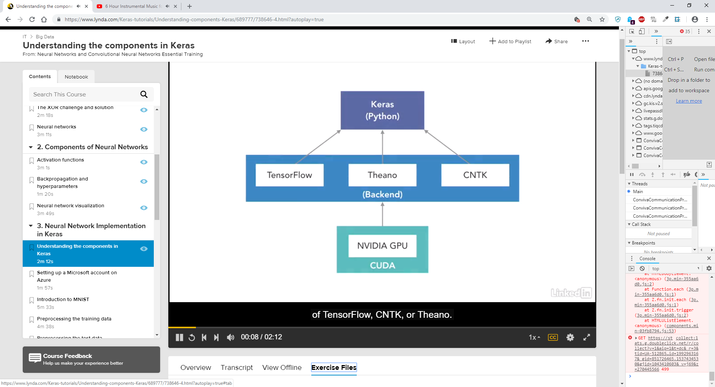

## Keras Components

### Model.compile()

Before training a model, you need to configure the learning process which is done via the compile method.   
  
The compile method receives three arguments:

* The Optimizer: An algorithm that, given a set of parameters, returns one with a smaller loss function
* Loss: The objective function for measuring the accuracy of performance error of a neural network.
* Metrics: the list of metrics: for any classification problem you will want to set metrics to accuracy.

## The Optimizer

You can call the optimizer by name using default parameter values, or you can instantiate an instance of the optimizer before passing it to the model.compile() function.   
  
  
Common Optimizers:  
  
 - SGD: Stochastic Gradient Descent Optimizer

includes support for momentum, learning rate decay and Nesterov momentum.

* RMSProp – good choice for recurrent neural networks.
* Adam – an algorithm for first-order gradient-based optimization of stochastic objective functions.

## Loss

Mean_squared_error: regression problem

Computes the element wise square difference between the two tenses.   
  
categorical_crossentropy: when your target has multiple classes  
  
 computes the categorical crossentropy between predictions and targets, often used when target has multiple classes.

Binary_crossentropy: when your target has two classes  
  
 Computes the binary crossentropy between predictions and targets, often used when target has two classes.

Remember that a metric is a function that is used to judge the performance of your model. For any classification problems, you will be wanting to use metrics as accuracy.  
  
  
  
  
  
  
  
  
  
  
An introduction to neural networks, Kevin Gurney (University of Sheffield 1997)

Chapter 1 page 1 line 18 -  
“A neural network is an interconnected assembly of simple processing elements, *units* or *nodes*, whose functionality is loosely based on the animal neuron. The processing ability of the network is stored in the interunit connection strengths, or weights, obtained by a process of adaptation to, or learning from, a set of training patterns”  
  
Human brain consists of 10^11 (100 billion) nerve cells

Neurons communicate via electrical signals which are small short-lived impulses in the voltage of the cell wall or membrane.

Interneuron connections are mediated via electrochemical junctions called Synapses.   
  
  
Synapse - In the nervous system, a **synapse** is a structure that permits a neuron (or nerve cell) to pass an electrical or chemical signal to another neuron or to the target effector cell.  
  
Synapses are located on the branches of the cell, which are referred to as dendrites.

Each neuron typically receives many thousands of connections from other neurons and is therefore constantly receiving a multitude of incoming signals which eventually reach the cell body.

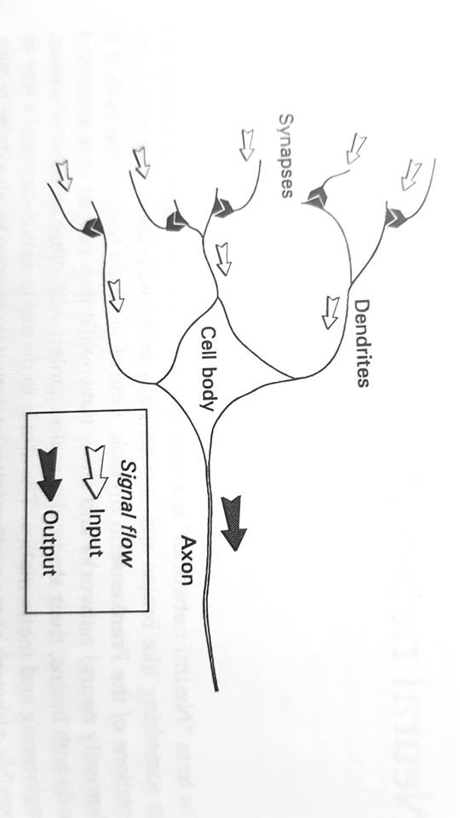

Chapter 1 page 2 line 2- in the cell body the signals are integrated or summed together in some way.  
“Here, they are integrated or summed together in some way and, roughly speaking, if the resulting signal exceeds some threshold then the neuron will “fire” or generate a voltage impulse in response.”  
This signal is then transmitted via the a fibre known as the axom to other neurons.  
  
In determining whether or not a signal should be produced some incoming signals induce a inhibitory effect while others produce excitatory effects to encourage impulse generation

Chapter 1 page 2 line 8 –

“The distinctive processing ability of each neuron is then supposed to reside in the type – excitatory or inhibitory – and strength of its synaptic connections with other neurons”

This is the architecture we attempt to incorporate in neural networks referred to as “connectionist”.

. Artificial equivalents of biological neurons are the nodes (or units)

. Synapses are modelled by a single number or weight

. each input is multiplied by the weight (synapse) before being sent to the equivalent of the cell body

. In the body – the weights are summed together by simple arithmetic addition to supply a node activation.  
  
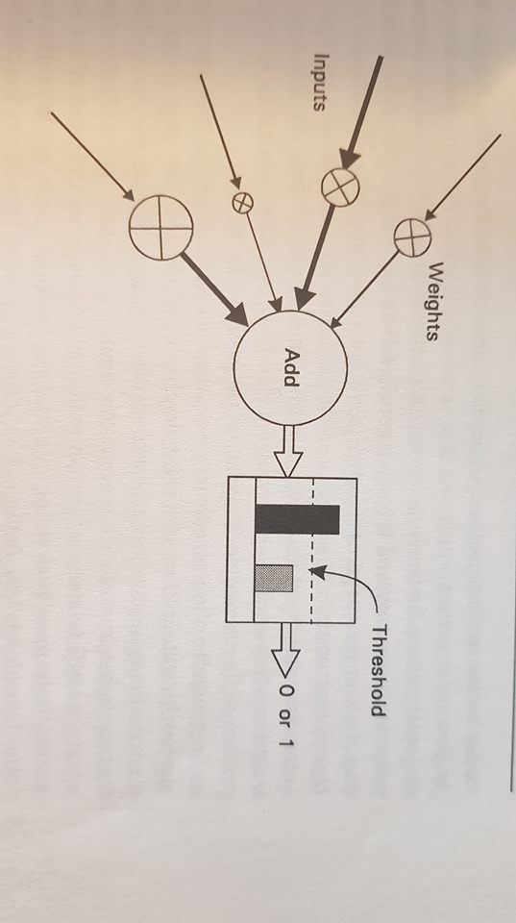  
  
.

. TLU – Threshold logic unit

. he activation is then compared with a threshold, if the activation exceeds the threshold a high-valued output (conventionally 1) is produced, otherwise a 0 is produced.

. In the figure the size of signals is represented by the width of the arrows

Simple Artificial Neuron:

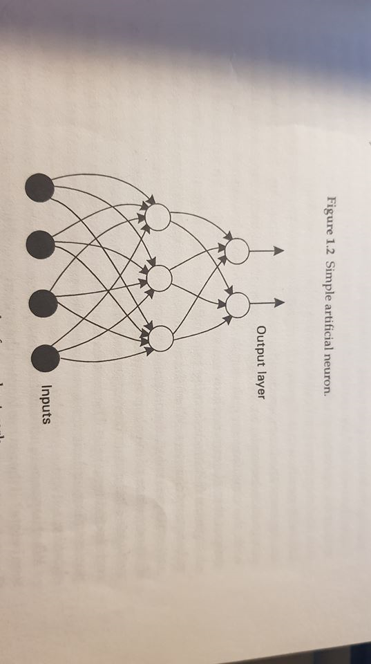

The feedforward structure above is only one of several available, typically used to place an input pattern into one of several classes according to the resulting pattern of outputs.

Feedforward example:

Input consists of encoding of light and dark in an image of handwritten letters.

Output layer may contain 26 nodes (one for each possible letter) to flag which letter class the input character is from.

This would be done by allocating one output node per class and requiring that only one such node fires whenever a pattern of the corresponding class is supplied as the input.

There is emphasis on learning from experience, real neurons synaptic strengths may be modified so that the behaviour of a neuron may change/adapt to a stimuli/input

Artificial Neurons equivalent of this adaptation is the modification of the weight values.

Chapter 1 page 4 line 17 –

“In terms of processing information, there are no computer programs here – the “knowledge” the network has is supposed to be stored in its weights, which evolve by a process of adaptation to stimulus from a set of pattern examples.”

Training Paradigm: Supervised Learning – An input pattern is shown to the net and its response compared to the target output.

The letter “A” May be input to the network, and the networks output compared with the classification code for “A”. The difference between the two patterns of output then determines how the weights (synapses) are altered.

Each particular recipe change constitutes a learning rule.

When the required updates have been made another pattern is presented, the output compared with the target and new changes made.

This sequence is iterated repetitively many times until the networks behaviour converges so that its response to each pattern is close to the corresponding target

The process as a whole , including any ordering of the pattern presentation or criteria for terminating the process, constitutes the training algorithm,

Good generalisation is one of the key properties of neural networks.

Artificial neuron Notes:

Synapse: Modelled by multiplying the signal with a weight.

Excitatory and inhibitory actions are modelled by positive and negative values respectively

Each product will now eb the analogue of a PSP (post-synaptic potential) and may be negative or positive depending on the sign of the weight. They should now be combined in a process to emulate this taking place in the axon hillock, this is done by simply adding them together to produce an activation (corresponding to the axon-hillock membrane potential)

Axon-hillock – the junction of the axon and soma (or cell body) this is where the action potentials are initiated if the membrane potential exceeds a threshold.

If we have n weights we form the products w1x1, w2x2… wnxn activation a can be expressed by the following equation

$$a=w_{1}x_{1}+w_{2}x_{2}+…+w_{n}x_{n}$$

Chapter 1 Page 14  
  
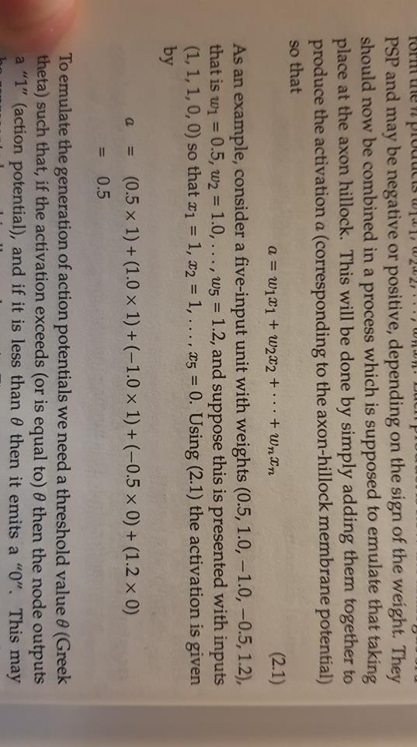

To emulate the generation of action potentials a threshold value of 0 is needed (also known as the Greek Theta) such that if the activation exceeds this threshold or is equal to it then the node outputs a “1” otherwise a “0” is output.

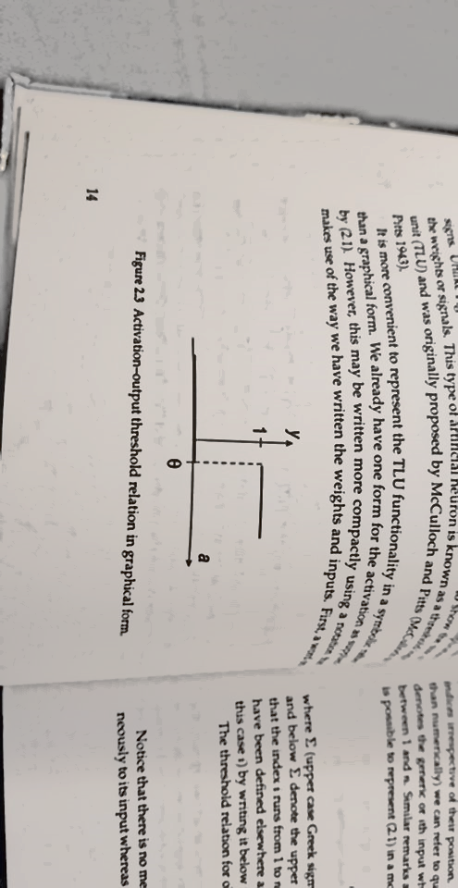

This relation is sometimes known as a step function or hard-limiter.

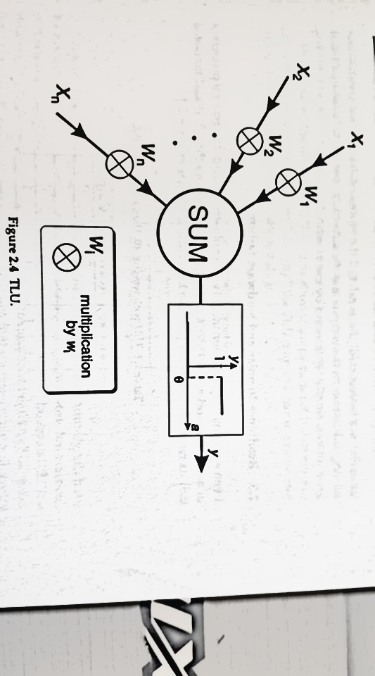

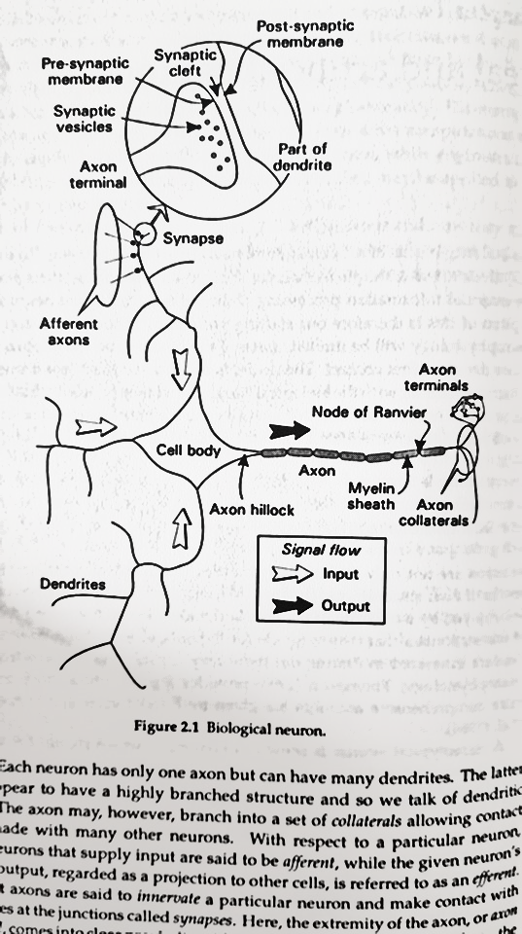

We can represent a biological neuron as such in a more compact form via the following equation

$$a= \sum_{i=1}^{n}{w_{i}x_{i}}$$

In writing the index symbolically rather than numerically we can refer to quantities generically allowing for our representation to be written in this compact form where Σ donates summation.

Σ – Sigma Symbol

|  |  |  |  |
| --- | --- | --- | --- |
| *X1* | *X*2 | Activation | Output |
| 0 | 0 | 0 | 0 |
| 0 | 1 | 1 | 1 |
| 1 | 0 | 0 | 0 |
| 1 | 1 | 1 | 1 |

In nonlinear systems such as the TLU the threshold does not care how much theta is exceeded by or preceded by.   
  
Take a simple two -input TLU with weights (0,1) and a threshold of 0.5 its response to all four input sets are shown below.  
  
TLU with weights (0,1) and threshold 0.5

If we then suppose our hardware which implements the TLU is faulty so that the weights are not held to at their true values and instead are encoded as (0.2, 0.8) the revised TLU functionality does not care about the changes so long as they do not cross the threshold, hence the table remains the same other than the activation values.   
  
  
TLU with weights (0.2, 0.8) and threshold 0.5

|  |  |  |  |
| --- | --- | --- | --- |
| *X1* | *X*2 | Activation | Output |
| 0 | 0 | 0 | 0 |
| 0 | 1 | 0.8 | 1 |
| 1 | 0 | 0.2 | 0 |
| 1 | 1 | 1 | 1 |

This is a direct characteristic of non-linear systems. In linear systems the output is proportional to the input.

Chapter 2 page 16 line 19

Nonlinear relations do not obey a proportionality restraint so the *magnitude* of the change in output does not necessarily reflect that of the input.

This means if the activation changes from 0 to 0.2 (a change of 0.2) there will be no difference to the output. However, if it were to change from 0.49 to 0.51 (a difference of 0.02) the output would suddenly alter from 0 to 1.

TLU with degraded signal output

|  |  |  |  |
| --- | --- | --- | --- |
| *X1* | *X*2 | Activation | Output |
| 0.2 | 0.2 | 0.2 | 0 |
| 0.2 | 0.8 | 0.8 | 1 |
| 0.8 | 0.2 | 0.2 | 0 |
| 0.8 | 0.8 | 0.8 | 1 |

Should the input be degraded in some way (possibly due to noise or power loss) the resulting TLU function is the same due to nonlinearity.

Eventually if there is enough signal loss to change the weights or/and signals significantly we will come across what is known is “graceful degradation” yielding incorrect responses. The number of TLU units giving these incorrect responses will also increase.

Real neurons are believed to encode their signal values in patterns of action potential firing.

1. Shows a continuous stream of action potential spikes while
2. Shows a pattern in which a series of pulses is followed by a quiescent period

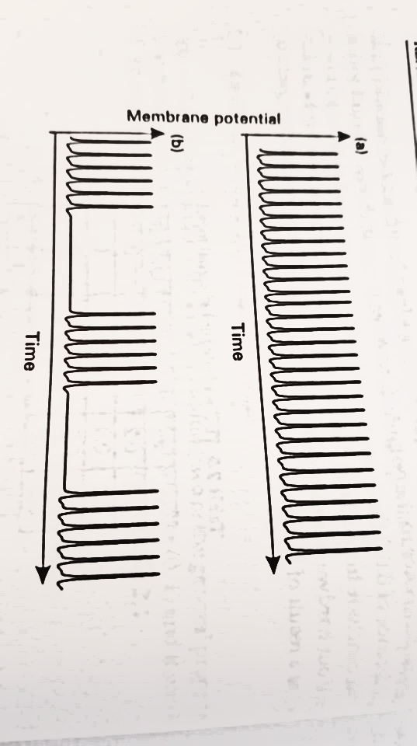

A continuous stream such as (a) can be characterised by the frequency of occurrence of action potential in pulses per second.

If *f* is the frequency of neural firing then we know *f* is bound below by zero and above by some max value *fmax which is governed by the duration of the inter-spike refractory period.*